VEERESH G DANDAGI

Email: [veereshgd4@gmail.com](mailto:veereshgd4@gmail.com)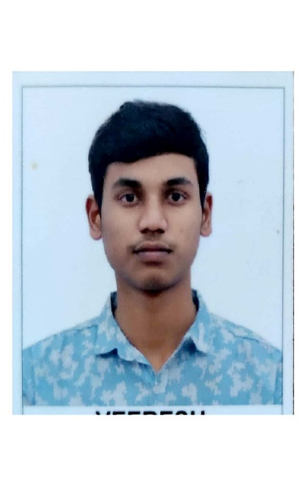

Contact Number: 6361962823

Objective:

Seeking a challenging career with a progressive organization that provides an opportunity to capitalize my technical skills and abilities in the field of information technology.

Education Qualification:

|  |  |  |  |  |
| --- | --- | --- | --- | --- |
| Course | Institute | University | Year of passing | Percentage of marks obtained/CGPA |
| BE (Civil Engineering) | SDM college of Engineering & Technology | Autonomous College under VTU, Belagavi | 2022(pursuing) | 8.54 |
| PUC | Nisarga Pre University Science College, Gulbarga | Karnataka State Board | 2018 | 80% |
| SSLC | Government High School Kollur. | Karnataka State Board | 2016 | 78.72% |

Academic Projects:

1. Minor Project Report on Application of Smart materials in Civil Engineering,

This project is aimed at monitor the civil engineering structures to evaluate their durability.

Monitor the integrity of Bridges, Dams, offshores oil drilling towers where fiber-optic sensors embedded in the structures are utilized to identify the trouble areas.

1. Extensive Survey

(a) NEW TANK PROJECT

Finding capacity of reservoir

* With using Contour Maps

1. Highway Project

* Finding reduced level with using Profile levelling

Technical Skills:

* Auto Cad
* Basics of C Language
* HTML
* Basic skills: MS word, MS excel & various communication skills.

Hobbies:

Reading books, Gardening.

Personal Details:

Father’s name: Gururaj Dandagi

Mother’s name: Manikamma Dandagi

DOB: 8/6/2000

Languages known: English, Kannada, Hindi

Address: AT-Maradagi(N),

Post-Kollur,

TALUK-Chittapur,

. DIST-Gulbarga,

PIN- 585218.

Declaration:

I hereby declare that the above information is true, correct to the best of my knowledge.